Resolving Error “CT slice spacing must be uniform”

# Purpose

Occasionally, Mobius gives the following error when DICOM files are uploaded for a plan check:

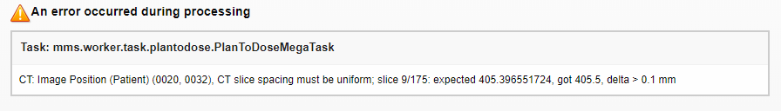

We can eliminate the error by excluding the problem slice from the DICOM files that are uploaded to Mobius. This procedure describes how to export from RayStation and then upload only the slices with uniform spacing.

# Steps

1. Export DICOM data from RayStation to a file.

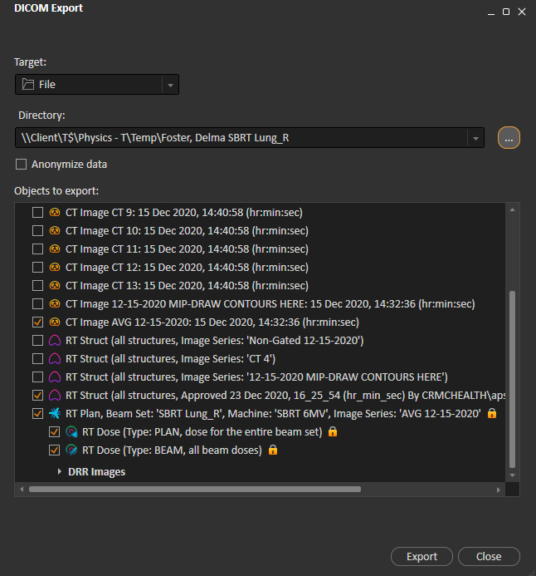

1. Note the problem slice in the error message. In the below screenshot, this is slice 9. Add 1 to this number.



1. Navigate to the folder to which you exported the DICOM files. Sort files by ascending filename.

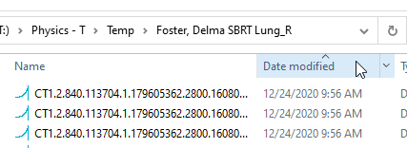

1. Delete the file with the problematic slice. In the example, this is the 10th file.

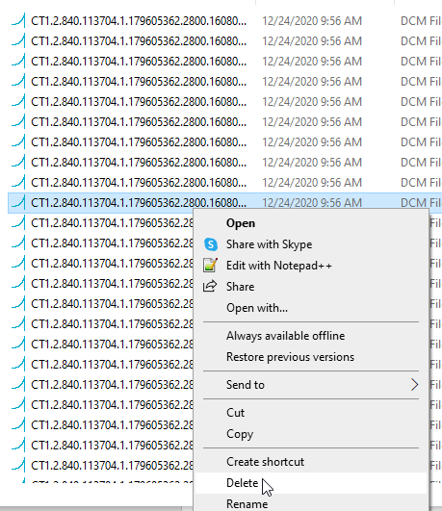

1. Create a zip file of the folder.

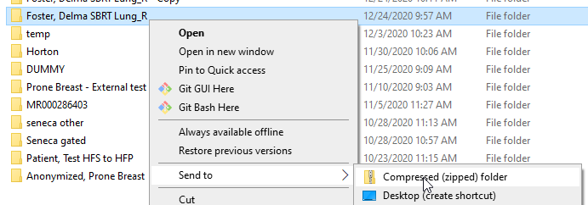

1. Upload the zip file to Mobius. See procedure “Manually Upload DICOM Files to Mobius,” starting with step 3.